**Motivation**

* Motivation is a psychological aspect that arouses, sustains and regulates human behavior. Motivation is the process of creating willingness among the workers to do the assigned jobs according to the best of their skill and efficiency. It is an inner state that stimulates energy and creativeness to do something effectively.
* Motivation is a process that starts with a psychological and physiological deficiency or need. It is the process of stimulating and encouraging individuals to perform the task in efficient manner. It enhances job satisfaction and goal achievement of organization and individual. As a result, it increases productivity in an organization.
* **Features/Nature of Motivation**
* 1. Goal oriented process
* 2. Positive or negative
* 3. Continuous function
* 4. Psychological phenomenon
* 5. Complex function
* 6. Motivation and satisfaction are related
* 7. Situational and dynamic
* 8. Holistic
* 9. Core of management
* **Process of Motivation:**
* 
* **Importance of Motivation:**
* 1. Optimum use of resources
* 2. Creation of interest and willingness
* 3. Higher productivity
* 4. Goal achievement
* 5. Facilitates organizational change
* 6. Satisfaction of employees
* 7. Builds friendly relationship
* 8. Minimize disputes
* 9. Minimize supervision cost
* **Types of Motivation:**
* **Positive motivation**:
* If a person gets incentives and rewards for higher performance, then such technique of motivation is called positive motivation. Positive motivation is the type of motivation a person feels when he/she expects a certain reward. Positive motivation technique is considered as a better motivational technique for modern business organizations.
* **Negative motivation:**
* Negative motivation is based on fear and punishment for poor performance. Negative motivation is the type of feeling a person gets when he/she expects punishment. Warning, threats, demotion, pay cut, transfer in remote area, etc. are few examples of negative motivation.
* **Content perspectives on Motivation**
* 1. Needs hierarchy theory
* 2. Two factor theory
* (Already discussed in unit 2)

**Process perspective on motivation:**

* **1. Expectation theory**
* **2. Equity theory**
* **3. Goal setting theory**
* **4. Reinforcement theory of motivation**

**Expectation theory**

Expectancy theory, initially put forward by **Victor Vroom** at the Yale School of Management, suggests that behavior is motivated by anticipated results or consequences. Vroom proposed that a person decides to behave in a certain way based on the expected result of the chosen behavior. For example, people will be willing to work harder if they think the extra effort will be rewarded.

In essence, individuals make choices based on estimates of how well the *expected*results of a given behavior are going to match up with or eventually lead to the *desired*results. This process begins in childhood and continues throughout a person’s life. Expectancy theory has three components: expectancy, instrumentality, and valence.

* **Expectancy** is the individual’s belief that effort will lead to the intended performance goals. Expectancy describes the person’s belief that “I can do this.” Usually, this belief is based on an individual’s past experience, self-confidence, and the perceived difficulty of the performance standard or goal. Factors associated with the individual’s expectancy perception are competence, goal difficulty, and control.
* **Instrumentality** is the belief that a person will receive a desired outcome if the performance expectation is met. Instrumentality reflects the person’s belief that, “If I accomplish this, I will get that.” The desired outcome may come in the form of a pay increase, promotion, recognition, or sense of accomplishment. Having clear policies in place—preferably spelled out in a contract—guarantees that the reward will be delivered if the agreed-upon performance is met. Instrumentality is low when the outcome is vague or uncertain, or if the outcome is the same for all possible levels of performance.
* **Valence** is the unique value an individual places on a particular outcome. Valence captures the fact that “I find this particular outcome desirable because I’m me.” Factors associated with the individual’s valence are needs, goals, preferences, values, sources of motivation, and the strength of an individual’s preference for a particular outcome. An outcome that one employee finds motivating and desirable—such as a bonus or pay raise—may not be motivating and desirable to another (who may, for example, prefer greater recognition or more flexible working hours).

Expectancy theory, when properly followed, can help managers understand how individuals are motivated to choose among various behavioral alternatives. To enhance the connection between performance and outcomes, managers should use systems that tie rewards very closely to performance. They can also use training to help employees improve their abilities and believe that added effort will, in fact, lead to better performance.

**Advantages of the Expectancy Theory**

* It is based on self-interest individual who want to achieve maximum satisfaction and who wants to minimize dissatisfaction.
* This theory stresses upon the expectations and perception; what is real and actual is immaterial.
* It emphasizes on rewards or pay-offs.
* It focuses on psychological extravagance where final objective of individual is to attain maximum pleasure and least pain.

**Limitations of the Expectancy Theory**

* The expectancy theory seems to be idealistic because quite a few individuals perceive high degree correlation between performance and rewards.
* The application of this theory is limited as reward is not directly correlated with performance in many organizations. It is related to other parameters also such as position, effort, responsibility, education, etc.

**Implications of the Expectancy Theory**

* The managers can correlate the preferred outcomes to the aimed performance levels.
* The managers must ensure that the employees can achieve the aimed performance levels.
* The deserving employees must be rewarded for their exceptional performance.
* The reward system must be fair and just in an organization.
* Organizations must design interesting, dynamic and challenging jobs.
* The employee’s motivation level should be continually assessed through various techniques such as questionnaire, personal interviews, etc.

**Equity theory**

Equity theory is central to understanding how employees’ motivation in the workplace is influenced by their perception of **fairness**. According to this theory, employees maintain a mental record, akin to a ‘ledger,’ that keeps track of what they contribute to their job and what they receive in return. These contributions or ‘**inputs**‘ could range from the amount of effort they put into tasks, their skill level, educational background, and overall work experience. In contrast, ‘**outputs**‘ or rewards can include things like salary, additional benefits, and opportunities for career advancement.

When it comes to gauging their level of motivation and job satisfaction, employees often compare their own **input-output balance** to that of their co-workers. If an employee feels that this balance is skewed in comparison to others, there’s a high chance they’ll become less enthusiastic and content with their job role. This could, in turn, affect their

However, if an employee thinks that their contributions and rewards are on par or better than their colleagues, they are likely to feel a higher sense of motivation and job satisfaction. This insight, grounded in **equity theory**, can be a useful tool for managers and business owners to ensure a motivated and content workforce.

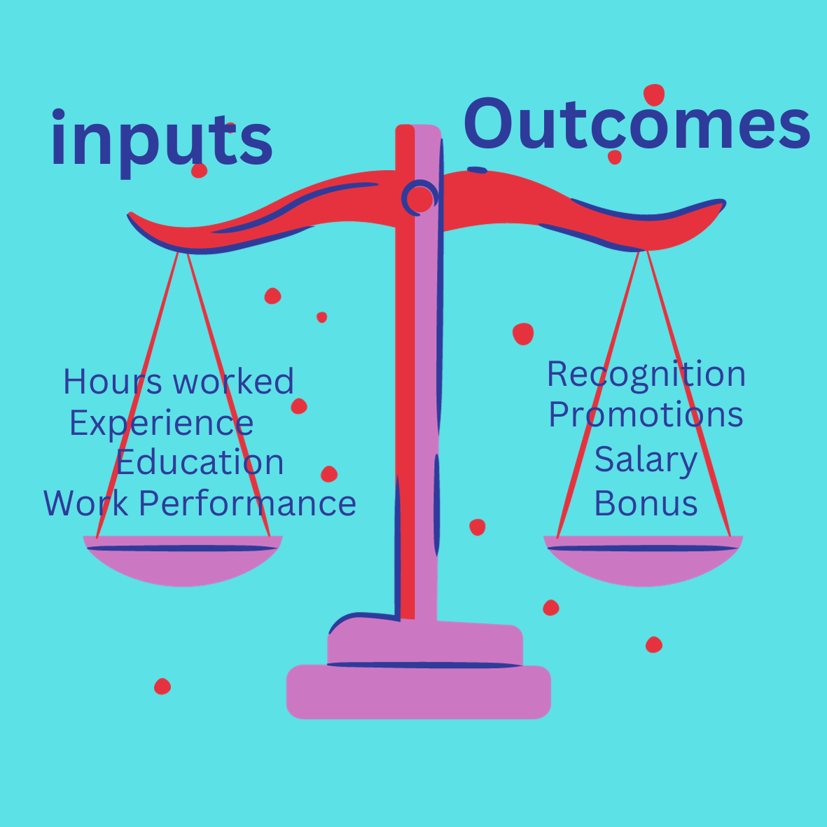

Equity Theory: Inputs should balance with outcomes

## Components Of The Equity Theory Of Motivation

The equity theory of motivation fundamentally rests on two core concepts: the effort a person invests, often called ‘inputs’, and the rewards a person receives, known as ‘outcomes’. These two components play a critical role in shaping an employee’s level of motivation.

### Inputs

Inputs, they can be broadly defined as the contributions an individual makes to secure some form of reward. This can range from the hours spent working and the responsibilities taken on, to the level of loyalty exhibited toward an organisation and the overall enthusiasm for the job at hand. Employees often make a distinction between elements they can control, such as punctuality and communication skills, and those that are beyond their control, like the level of training provided by the employer or their years of service in the company.

### Outcomes – Outputs

Outcomes are the compensations or benefits received in exchange for these contributions. Sometimes these rewards can be easily quantifiable, like a paycheck, job stability, or fringe benefits like healthcare packages and time off. However, not all outcomes can be measured in concrete terms. Some are more elusive but equally significant, like gaining respect from colleagues, building a solid professional reputation, or deriving a sense of satisfaction and pride from your own work.

It’s essential that the worth assigned to the outcomes should, in an ideal world, mirror the significance of the inputs. For example, someone who has invested in higher education might anticipate that their advanced qualifications will lead to superior job prospects.

## How To Apply The Equity Theory Of Motivation In The Workplace

Understanding your team’s motivation is crucial, and the framework provided by Equity Theory can be quite enlightening. To implement this theory effectively in your workplace, consider these three core strategies:

1. **Establish fairness:** If you are in a position of seniority, one of your first priorities should be to set up a fair reward system. Make it a point to offer equal rewards for equal amounts of work. Regular team meetings can be a good venue to make sure everyone feels recognised for their contributions.
2. **Benchmark compensation:**Salary is often at the heart of how team members judge their treatment at work. To keep your team satisfied, align your compensation packages with the market standards. Doing a bit of market research, for example, by looking at online databases to check competitive salaries, can arm you with the necessary information for defining appropriate compensation levels.
3. **Understand individual preferences and emotional states:** Different team members are motivated by different things. Some may put a higher value on monetary rewards, while others might be more motivated by job satisfaction or opportunities for growth. Personalised discussions can offer you a clear idea of what each team member values most, allowing you to formulate a plan that keeps everyone engaged and satisfied. Similarly, emotional factors can also come into play. If a team member feels under-rewarded, they may develop feelings of resentment that could lead to decreased performance. On the other hand, over-rewarding can cause guilt, affecting morale in a different way. Therefore, emotional considerations should not be underestimated when applying Equity Theory.

**Goal setting theory**

Goal-setting theory of motivation states that specific and challenging goals, along with appropriate feedback, contribute to higher and better task performance.

Goals indicate and give direction to an employee about what needs to be done and how much effort is required to be put in. In the 1960s, Edwin Locke put forward the goal-setting theory of motivation. The theory states that goal setting is essentially linked to task performance.

**7 Goal-Setting Theory Principles**

7 principles of goal setting theory are;

**1. Clarity**

Clear goals are measurable and unambiguous.

When a goal is dear and specific, with a definite time set for completion, there is less misunderstanding about what behaviors will be rewarded.

“Reduce job turnover by 15%” or “Respond to employee suggestions within 48 hours” are examples of dear goals.

**2. Challenge**

One of the most important characteristics of goals is the level of challenge.

People are often motivated by achievement, and they’ll judge a goal based on the significance of the anticipated accomplishment.

Rewards typically increase for more difficult goals. If you believe you’ll be well compensated or otherwise rewarded for achieving a challenging goal, that will boost your enthusiasm and drive to get it done.

If an assignment is easy and not viewed as very important – and if you or your employee doesn’t expect the accomplishment to be significant – then the effort may not be impressive.

**3. Commitment**

Goals must be understood and agreed upon if they are to be effective. Employees are more likely to “buy into” a goal if they feel they were part of creating that goal.

The notion of participative management rests on involving employees in setting goals and making decisions.

**4. Feedback**

In addition to selecting the correct type of goal, an effective goal program must also include feedback. Feedback provides opportunities to clarify expectations, adjust goal difficulty, and gain recognition.

It’s important to provide benchmark opportunities or targets so individuals can determine how they’re doing for themselves.

**5. Task Complexity**

The last factor in the goal-setting theory introduces two more requirements for success. For goals or assignments that are highly complex, take special care to ensure that the work doesn’t become too overwhelming.

Goal-setting theory has certain eventualities, such as Self-efficiency and Goal commitment.

**6. Self-Efficiency**

Self-efficiency is the individual’s self-confidence and faith that he has potential.

When a person performs a task, the higher the level of self-efficiency, the greater the efforts will be in the individual when they face challenging tasks.

While lower the level of self-efficiency less will be the efforts put in by the individual, or he might even quit while meeting challenges.

**7. Goal Commitment**

The goal-setting theory assumes that the individual is committed to the goal and will not leave the goal. The goal commitment is dependent on the following factors:

Goals are made open, known, and broadcasted.

Goals should be set-self by individuals rather than designated.

The individual’s set should be consistent with organizational goals and vision.

**Features of Goal Setting Theory**

* 1. The willingness to work towards the attainment of the goal is the main source of job motivation. Clear, particular, and difficult goals are greater motivating factors than easy, general, and vague goals.
  2. Specific and clear goals lead to greater output and better performance. Unambiguous, measurable, and clear goals accompanied by a deadline for completion avoid misunderstanding.
  3. Goals should be realistic and challenging. This gives an individual a feeling of pride and triumph when he attains them and sets him up for the attainment of the next goal. The more challenging the goal, the greater the reward generally, and the more is the passion for achieving it.
  4. Better and appropriate feedback on results directs the employee behavior and contributes to higher performance than an absence of feedback. Feedback is a means of gaining reputation, making clarifications, and regulating goal difficulties. It helps employees to work with more involvement and leads to greater job satisfaction.
  5. Employees’ participation in goals is not always desirable. Participation in setting the goal, however, makes the goal more acceptable and leads to more involvement.

**Advantages of Goal Setting Theory**

* 1. Goal-setting theory is a technique used to raise incentives for employees to complete work quickly and effectively.
  2. Goal setting leads to better performance by increasing motivation and efforts, but also by increasing and improving the feedback quality.

**Limitations of Goal Setting theory**

1. At times, the organizational goals conflict with the managerial goals. Goal conflict has a detrimental effect on the performance if it motivates incompatible action drift.
2. Very difficult and complex goals stimulate riskier behavior.
3. If the employee lacks the skills and competencies to perform actions essential for the goal, the goal-setting can fail and undermine performance.
4. There is no evidence to prove that goal-setting improves job satisfaction.

# Reinforcement Theory of Motivation

Reinforcement theory of motivation was proposed by **BF Skinner** and his associates. It states that individual’s behaviour is a function of its consequences. It is based on “law of effect”, i.e, individual’s behaviour with positive consequences tends to be repeated, but individual’s behaviour with negative consequences tends not to be repeated.

**Reinforcement theory of motivation overlooks the internal state of individual**, i.e., the inner feelings and drives of individuals are ignored by Skinner. This theory focuses totally on what happens to an individual when he takes some action.

Thus, according to Skinner, the external environment of the organization must be designed effectively and positively so as to motivate the employee.

This theory is a strong tool for analyzing controlling mechanism for individual’s behaviour. However, it does not focus on the causes of individual’s behaviour.

The managers use the following methods for controlling the behaviour of the employees:

|  |  |
| --- | --- |
|  | **Positive Reinforcement-** This implies giving a positive response when an individual shows positive and required behaviour. For example - Immediately praising an employee for coming early for job. This will increase probability of outstanding behaviour occurring again.  Reward is a positive reinforce, but not necessarily. If and only if the employees’ behaviour improves, reward can said to be a positive reinforcer. Positive reinforcement stimulates occurrence of a behaviour. It must be noted that more spontaneous is the giving of reward, the greater reinforcement value it has. |
|  | **Negative Reinforcement-** This implies rewarding an employee by removing negative / undesirable consequences. Both positive and negative reinforcement can be used for increasing desirable/required behaviour. |
|  | **Punishment-** It implies removing positive consequences so as to lower the probability of repeating undesirable behaviour in future.  In other words, punishment means applying undesirable consequence for showing undesirable behaviour.  For instance - Suspending an employee for breaking the organizational rules. Punishment can be equalized by positive reinforcement from alternative source. |
|  | **Extinction-** It implies absence of reinforcements.  In other words, extinction implies lowering the probability of undesired behaviour by removing reward for that kind of behaviour.  For instance - if an employee no longer receives praise and admiration for his good work, he may feel that his behaviour is generating no fruitful consequence. Extinction may unintentionally lower desirable behaviour. |

### Implications of Reinforcement Theory

Reinforcement theory explains in detail how an individual learns behaviour. Managers who are making attempt to motivate the employees must ensure that they do not reward all employees simultaneously. They must tell the employees what they are not doing correct. They must tell the employees how they can achieve positive reinforcement.

Leadership/Leading

* Leading is to influence others’ behavior by directing, motivating, communicating, supervising and coordinating to achieve organizational objectives. It activates the organizational member to work effectively and efficiently for the attainment of organizational goals through directing, motivating, communicating, supervising and coordinating. The effectiveness of leadership depends on the ability, skills and quality of influencing others’ behavior. The person who leads others is a leader.
* Leadership is the process of influencing the behavior and performance of an individual or group. Effective leadership is helpful for attaining organizational, group and individual goals.

**Nature/Features of Leadership**

* 1. Influence the behavior of others
* 2. Reciprocal influence
* 3. Attainment of common goal
* 4. Continuous process
* 5. Situational behavior
* 6. Unequal distribution of authority